

Assessment Cover Page

Student Full Name | Yumiko Maria Bejarano Azogue
Student Number | 2024144
Module Title | Machine Learning for Business
Assessment Title | CA 1 – Capstone Project Proposal
Assessment Due Date | 11th September 2024
Date of Submission | 27th October 2024
Declaration
By submitting this assessment, I confirm that I have read the CCT policy on academic misconduct and understand the implications of submitting work that is not my own or does not appropriately reference material taken from a third party or other source.
I declare it to be my own work and that all material from third parties has been appropriately referenced.
I further confirm that this work has not previously been submitted for assessment by myself or someone else in CCT College Dublin or any other higher education institution.

Contents

Market Prediction and Segmentation with Apple Stock 4
1. Introduction 4
2. Motivation 4
3. Problem Domain Description 4
4. Project Objectives 4
5. Justification of the chosen Dataset 4
6. Clustering algorithms for segmentation (K-means and DBSCAN) 5
6.1. Comparison of results 6
7. Time Series Analysis 7
7.1. Initial exploration 7
7.2 Decomposition of Time Series Components 7
7.3 Stationarity and ADF Analysis 8
8. Parameter selection for the ARIMA model 9
8.1. ARIMA model performance 9
9. Conclusion 11
References 13

Figures

Figure 1: Simple visualization of K-means clustering applied to Apple stock data showing the distribution of clusters based on Closing Price and Volume. 5
Figure 2: Visualization for determining the optimal number of clusters using the Elbow Method and Silhouette Score, demonstrating the selection criteria for K-means clustering. 5
Figure 3: Visualization of DBSCAN clustering results showing density-based clusters and identified noise points in the Apple stock data. 6
Figure 4: Comparison metrics table showing evaluation results for both clustering algorithms (K-means and DBSCAN). 6
Figure 5: Side-by-side comparison of clustering results between K-means and DBSCAN, displaying the effectiveness of each algorithm. 6
Figure 6: Time series plot of Apple's stock closing prices from January 2020 to January 2024, showing the overall trend and major price movements. 7
Figure 7: Decomposition plot of the time series showing four components: Close, Trend, Seasonal, and Residual patterns in the stock data. 8
Figure 8: Results of the initial Augmented Dickey-Fuller test showing the non-stationarity of the original series. 8
Figure 9: Results of the Augmented Dickey-Fuller test after differencing, confirming the achievement of stationarity. 8
Figure 10: ACF and PACF plots used for identifying the appropriate parameters for the ARIMA model. 9
Figure 11: ARIMA model diagnostic plots showing residual analysis and model fit statistics. 10
Figure 12: Plot comparing actual versus predicted values from the ARIMA model. 10
Figure 13: Plot showing ARIMA model forecast with confidence intervals. 11
Figure 14: Visualization of the final forecast showing predicted future values and confidence bounds. 11

Market Prediction and Segmentation with Apple Stock

Introduction
Time series analysis and clustering are essential in finance to understand asset price developments and predict future behavior. This project uses historical data from Apple Inc. (AAPL) to implement time series models and clustering algorithms, with the aim of gaining insights into market behavior.
Number of words: 44.

Motivation
Given the volatility of the stock market, prediction techniques are crucial to anticipate trends and make informed decisions. Clustering, on the other hand, facilitates the identification of groups of data with common characteristics, which helps to better understand the underlying structure of the market. Apple, as one of the most influential companies globally, is an ideal case for this analysis due to its impact on the economy and the availability of high- quality data.
Number of words: 74

Problem Domain Description
The project focuses on financial analysis and computational science, specifically on time series analysis and clustering applied to stock markets. Capturing trends, seasonality and anomalies is crucial to developing robust predictive models. In addition, clustering allows segmenting data into groups that reveal hidden patterns useful to investors.
Number of words: 47

Project Objectives
The main objectives of the project include analyzing AAPL data from 2020 to 2024 to identify patterns, applying ARIMA models for price prediction, and comparing clustering algorithms such as K-means and DBSCAN to segment the data. The analysis will be done with visualizations to interpret the results.
Number of words: 47

Justification of the chosen Dataset
To The Apple dataset is well suited for its relevance, volume, and the complexity of the market it represents, allowing for effective application of ARIMA and clustering for prediction and segmentation of market behavior.
Number of words: 33

6. Clustering algorithms for segmentation (K-means and DBSCAN)
K-means is a clustering algorithm that assigns points to predetermined clusters by minimizing the distance to their centroids. This method is favored for its simplicity and efficiency, particularly when dealing with large datasets, making it a popular choice in financial data analysis. Additionally, K-means works well with spherical clusters, where data points are evenly distributed around a central point, such as in stock data based on closing prices and trading volumes.
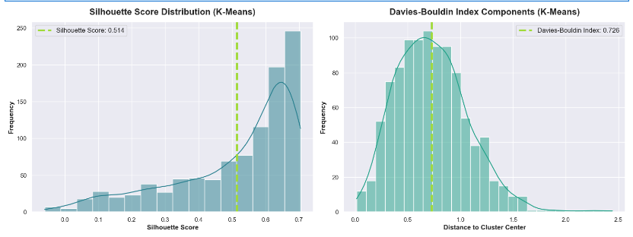
Figure 1: Simple visualization of K-means clustering applied to Apple stock data showing the distribution of clusters based on Closing Price and Volume.
To determine the optimal number of clusters, two approaches were utilized: the elbow method and the Silhouette method. The elbow method identifies the point at which inertia stabilizes, indicating that adding more clusters does not significantly improve the clustering outcome. Meanwhile, the Silhouette method corroborates this choice by measuring the internal coherence of the formed clusters, providing an additional layer of validation. These techniques combined ensure robust clustering results for financial datasets, such as Apple’s.
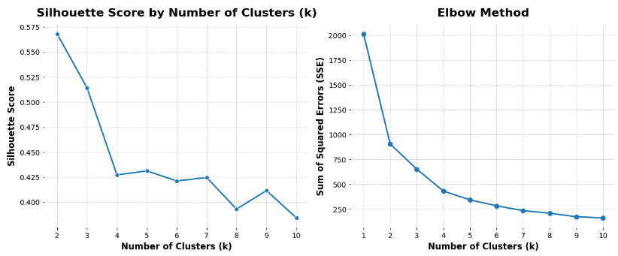
Figure 2: Visualization for determining the optimal number of clusters using the Elbow Method and Silhouette Score, demonstrating the selection criteria for K-means clustering.
DBSCAN (Density-Based Spatial Clustering of Applications with Noise) is another algorithm that detects density-based clusters, making it particularly useful for non-spherical structures and for handling noise or outliers, which are common in financial data. Unlike K-means, DBSCAN does not require the number of clusters to be specified beforehand, offering more flexibility when analyzing complex datasets.
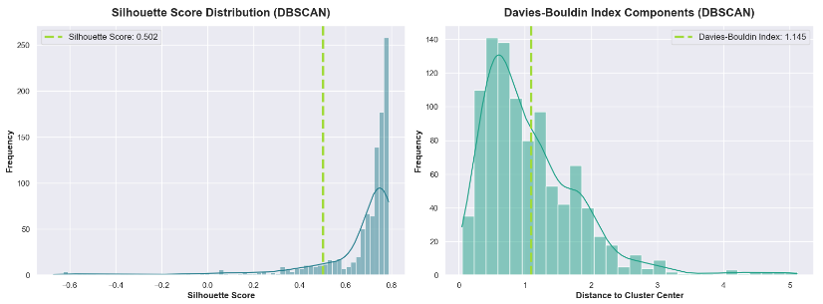
Figure 3: Visualization of DBSCAN clustering results showing density-based clusters and identified noise points in the Apple stock data.
The algorithm groups points that are close enough to each other, while those that do not meet the density criterion are classified as noise or anomalies. This makes DBSCAN a powerful tool for detecting irregularities in large datasets.

6.1. Comparison of results
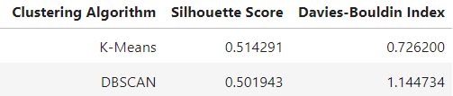
Figure 4: Comparison metrics table showing evaluation results for both clustering algorithms (K-means and DBSCAN).
Clustering with k-means appears to outperform DBSCAN. The Silhouette Score of 0.514 for k-means is slightly better than the 0.501 for DBSCAN, suggesting that k-means has more clearly defined clusters. Furthermore, the Davies-Bouldin Index of 0.726 for k-means is considerably lower than the 1.145 for DBSCAN, indicating that the clusters in k-means are less overlapping and better separated.
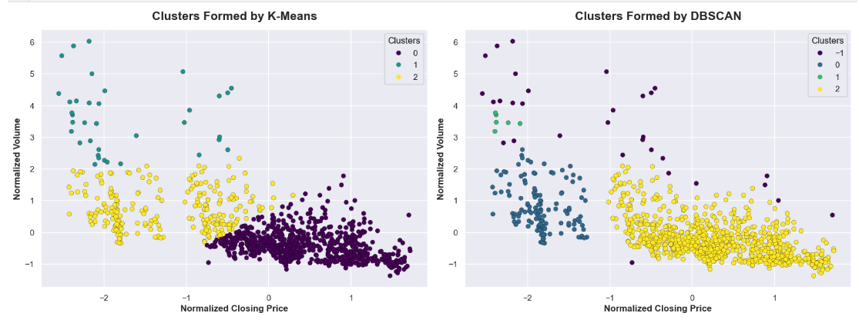
Figure 5: Side-by-side comparison of clustering results between K-means and DBSCAN, displaying the effectiveness of each algorithm.
Number of words: 296

7. Time Series Analysis

7.1. Initial exploration
The analysis of Apple's stock prices from January 2020 to January 2024 shows key details. During this time, the stock price grew from about $60 in 2020 to nearly $200 in 2023, showing strong growth. There were ups and downs, like a drop in 2022 before the stock went up again.
In early 2020, there was a sudden fall, probably due to COVID-19, followed by a quick recovery. We also see regular patterns that may be related to product launches or quarterly reports. This chart shows the stock’s changes, with both risks and growth, showing the need to consider external events and cycles in financial analysis.
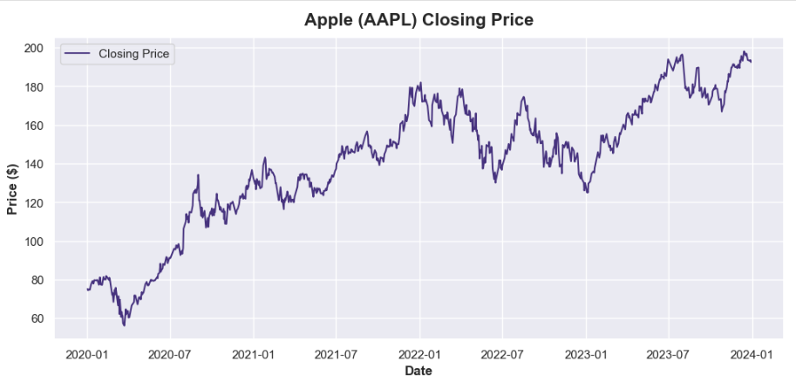
Figure 6: Time series plot of Apple's stock closing prices from January 2020 to January 2024, showing the overall trend and major price movements.

7.2 Decomposition of Time Series Components
The time series was split into four main parts: Close, Trend, Seasonal, and Resid. The Close part shows daily changes in prices. The Trend part shows the overall long-term direction, mostly going up with some drops and steady points. The Seasonal part shows short-term repeating patterns, and Resid shows random changes after removing trend and seasonality, centered around zero. This means the main patterns are captured.
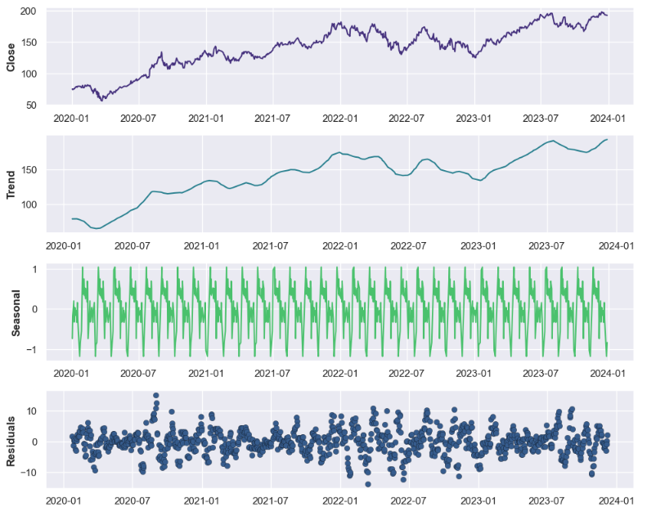
Figure 7: Decomposition plot of the time series showing four components: Close, Trend, Seasonal, and Residual patterns in the stock data.

7.3 Stationarity and ADF Analysis
To check if the series is stable, the Augmented Dickey-Fuller (ADF) test was used. With a high p-value in the original series, we see that it is not stable. After we used differentiation, the ADF test showed a very low p-value (0.0), which means the series became stable.
Figure 8: Results of the initial Augmented Dickey-Fuller test showing the non-stationarity of the original series.
Figure 9: Results of the Augmented Dickey-Fuller test after differencing, confirming the achievement of stationarity.
Number of words: 220

Parameter selection for the ARIMA model
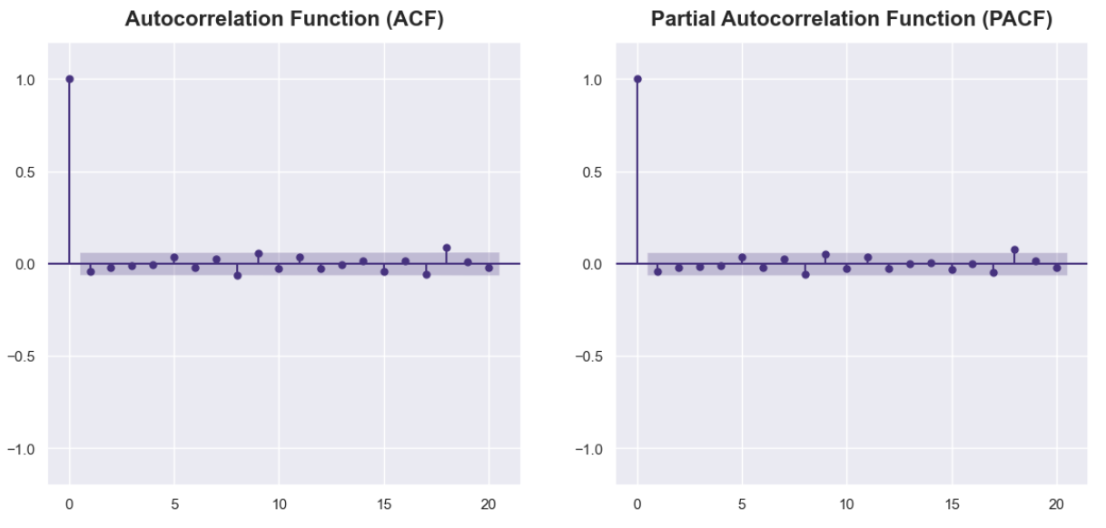
Figure 10: ACF and PACF plots used for identifying the appropriate parameters for the ARIMA model.
The parameters (p, d, q) of the ARIMA model were selected carefully to ensure accurate forecasting. Each parameter plays a critical role in capturing different aspects of the time series data:
- Autoregressive (AR): This component models the influence of past values on the current value. For this model, p=1 was chosen, indicating that the current value is influenced by the previous data point. This value was identified based on the partial autocorrelation function (PACF) plot, which suggested that a single lag was sufficient.
- Differencing (I): The differencing parameter helps to stabilize the time series by making it stationary. Stationarity implies that the statistical properties of the series, such as mean and variance, remain constant over time. In this analysis, applying a first difference (d = 1) effectively achieved stationarity, as confirmed by the Augmented Dickey-Fuller test.
- Moving Average (MA): This component corrects for past errors, adjusting the forecast based on recent prediction errors. Here, q=1 was selected from the autocorrelation function (ACF) plot, which indicated that one lag of past errors would best capture the data's short-term noise.

8.1. ARIMA model performance
The ARIMA(1,1,1) model provides a strong fit for our time series data. The low AIC (4813.129) and BIC (4827.867) values indicate a balance between accuracy and simplicity. While the AR (0.3929) and MA (-0.4353) coefficients are not highly significant (P values > 0.05), suggesting room for minor adjustments, the low residual variance (sigma2 = 6.9956) shows the model captures data patterns effectively.
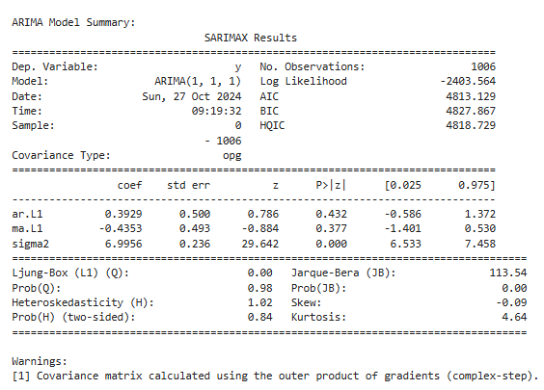
Figure 11: ARIMA model diagnostic plots showing residual analysis and model fit statistics.
Diagnostic plots confirm approximately normal residuals with no significant autocorrelation, supporting the model’s robustness. The graph comparing predictions with actual data shows good alignment, with the forecast confidence intervals illustrating uncertainty. Although residuals deviate slightly from normality, this does not significantly impact prediction quality.
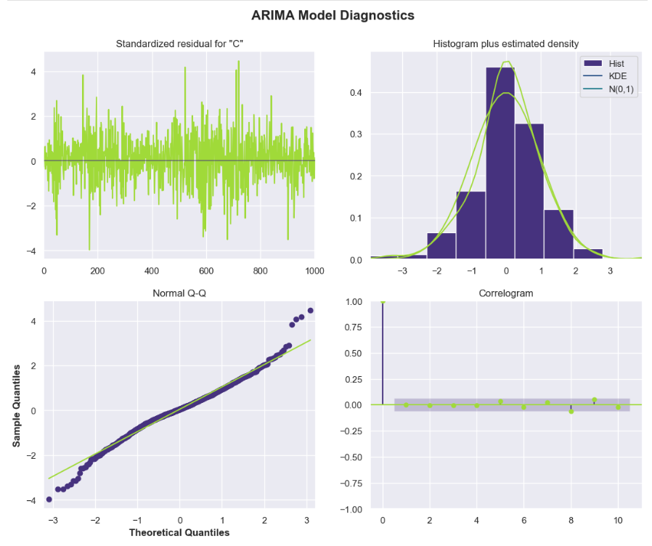
Figure 12: Plot comparing actual versus predicted values from the ARIMA model.
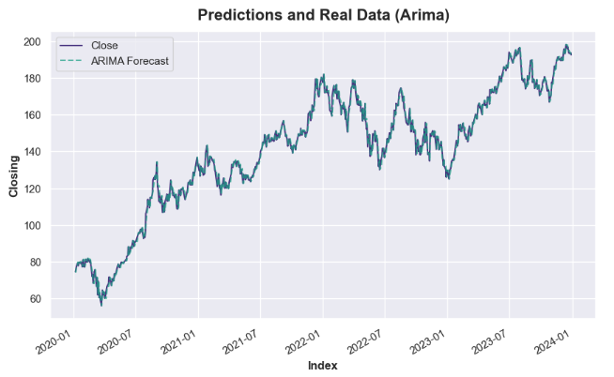
Figure 13: Plot showing ARIMA model forecast with confidence intervals.
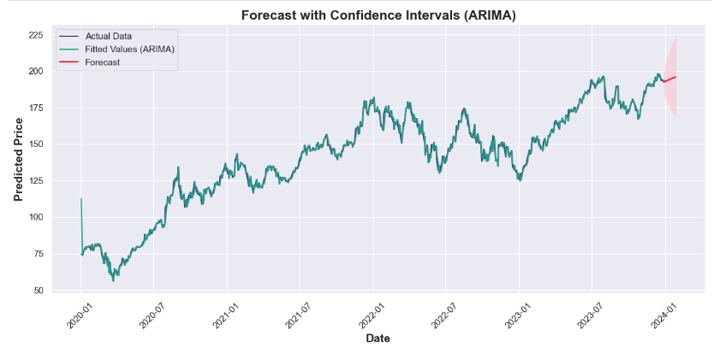
Figure 14: Visualization of the final forecast showing predicted future values and confidence bounds.
In summary, the ARIMA(1,1,1) model is suitable for reliable short-term forecasts, capturing essential patterns in the data.
Number of words: 297

Conclusion
K-Means and DBSCAN algorithms were implemented to perform the clustering analysis. K-Means obtained a higher Silhouette score (0.514) compared to DBSCAN (0.501), reflecting a better separation of the clusters. However, the Davies-Bouldin index was lower for DBSCAN (1.14 vs 0.72 in K-Means), suggesting that the clusters in DBSCAN present lower internal similarity.
For the time series analysis, the ARIMA(1, 1, 1) model was used after transforming the non-stationary data to stationary data by applying differencing. The model presented stable predictions with an AIC value of 4813.1, reflecting a good fit. The Jarque-Bera test showed a slight skewness in the distribution, although it did not significantly affect the quality of the predictions. ARIMA proved to be suitable for differenced data, allowing reliable forecasts in the absence of complex seasonal patterns.
Number of words: 117

References
Aroussi, R. (2023). yfinance: Yahoo! Finance market data downloader. [online] PyPI. Available at: https://pypi.org/project/yfinance/ [Accessed 25 Sep. 2024].
Chadfulton.com. (2017). Maximum Likelihood Estimation — State Space Estimation of Time Series Models in Python: Statsmodels 0.1 documentation. [online] Available at: https://www.chadfulton.com/fulton_statsmodels_2017/sections/4-maximum_likelihood_estimation.html [Accessed 26 Oct. 2024].
Formación en ciencia de datos | DataScientest.com. (2022). Machine Learning & Clustering: el algoritmo DBSCAN. [online] Available at: https://datascientest.com/es/machine-learning-clustering-dbscan [Accessed 9 Oct. 2024].
Foy, P. (2021). Unsupervised Learning: Stock Market Clustering with K-Means. [online] MLQ.ai. Available at: https://blog.mlq.ai/stock-market-clustering-with-k-means/ [Accessed 25 Sep. 2024].
Instituto Nacional de Educación Financiera - iNEF. (2023). ¿Qué es un clustering y cómo puede ayudarte en tus finanzas? Descúbrelo aquí. [online] Available at: https://inef.es/fundamentos-de-la-educacion-financiera/que-es-un-clustering [Accessed 22 Oct. 2024].
Mauricio, J. (2007). Análisis de Series Temporales. [online] Available at: https://www.ucm.es/data/cont/docs/518-2013-11-11-JAM-IAST-Libro.pdf [Accessed 30 Sep. 2024].
Sayah, F. (2022). Time Series Analysis: A Hands-On Guide Using Pandas and Matplotlib with Yahoo Finance Data. [online] Medium. Available at: https://medium.com/@sayahfares19/time-series-analysis-with-pandas-and-matplotlib-yahoo-finance-data-fc4ad67c268c [Accessed 25 Sep. 2024].
Stock Analysis (2024). Apple Inc. (AAPL) Stock Price, Quote & News. [online] Stock Analysis. Available at: https://stockanalysis.com/stocks/aapl/ [Accessed 8 Oct. 2024].
Yahoo Finance (2024). AAPL : Summary for Apple Inc. - Yahoo Finance. [online] YahooFinance. Available at: https://finance.yahoo.com/quote/AAPL [Accessed 25 Sep. 2024].
Chatgpt.com. (2024). Available at: https://chatgpt.com/share/681cfb33-4726-43ca-8d24-3a2431901e84 Get instant answers, find inspiration, learn something new.

Word Count Summary by Section
- Introduction: 44 words
- Motivation: 74 words
- Problem Domain Description: 47 words
- Project Objectives: 47 words
- Justification of the chosen Dataset: 33 words
- Clustering Algorithms for Segmentation (K-means and DBSCAN): 296 words
- Time Series Analysis: 220 words
- Parameter Selection for the ARIMA Model: 297 words
- Conclusion: 117 words
Total Word Count : 1175 words

